

Anaphylaxis and Allergies in School Policy

Ghost Hill Infant and Nursery School

Approved by: | Rebecca Westall | Date: June 2026
Last reviewed on: | New School Policy
Next review due by: | September 2027

Contents
- Policy Statement
- Scope
- Legal and Statutory Framework
- Aims of the Policy
- Roles and Responsibilities
- Identification and Individual Care Plans
- Staff Training (Mandatory)
- Emergency Medication (Adrenaline Auto-Injectors)
- Emergency Response to Anaphylaxis
- Risk Reduction and Prevention
- Risk Assessment
- Record-Keeping and Communication
- Policy Review

1. Policy Statement
Ghost Hill Infant and Nursery School is committed to providing a safe, inclusive, and supportive environment for all pupils with allergies, including those at risk of anaphylaxis. We recognise that allergic reactions can be life-threatening and require rapid and confident action.
This policy sets out how the school prevents allergic reactions, recognises early symptoms, and responds effectively to emergencies, in line with Benedict’s Law, statutory guidance from the Department for Education, and best practice from national allergy organisations.

2. Scope
This policy applies to:
- All pupils with diagnosed or suspected allergies
- All staff (teaching, support, catering, site, transport)
- Visitors, contractors, and external providers
- On-site activities, trips and visits*, clubs, and transport

*When checking prior to departure, if a pupil has forgotten their Adrenaline Auto Injector (AAI), the new requirement to hold a spare adrenaline auto‑injector (AAI) does not automatically mean you should allow the child to go on the trip without their own prescribed AAI.

However, it does mean the decision should now be risk‑based rather than an automatic exclusion.

3. Legal and Statutory Framework
From 1 September 2026, Benedict’s Law introduces mandatory statutory guidance for allergy safety in all maintained schools and academies in England. Schools are expected to demonstrate compliance through clear policies, training, and systems.
This policy also supports existing duties under:
- Children and Families Act 2014 (supporting pupils with medical conditions)
- Equality Act 2010
- Health and Safety at Work etc. Act 1974
- Keeping children safe in Education 2025
- Trust Allergies and Anaphylaxis Policy

4. Aims of the Policy
- To reduce the risk of allergen exposure
- To ensure all staff can recognise and respond to allergic reactions and anaphylaxis
- To ensure rapid access to emergency medication, including AAI’s
- To promote a consistent, whole-school approach to allergy management
- To meet statutory requirements under Benedict’s Law

5. Roles and Responsibilities

Trust (Governing Body)
- Approves and monitors this policy
- Ensures statutory compliance and resourcing

Headteacher
- Ensures the policy is implemented and reviewed annually
- Ensures staff training and awareness
- Ensures effective procedures are in place at the school

Designated Medical / Allergy Lead
- Maintains records of pupils with allergies
- Oversees Individual Healthcare Plans (IHPs) and Allergy Action Plans
- Monitors medication storage and expiry dates

All Staff
- Attend allergy and anaphylaxis training
- Know which pupils are at risk and where emergency medication is stored
- Act immediately and confidently in an emergency

6. Identification and Individual Care Plans
- All pupils with diagnosed allergies must have an Individual Health Care Plan (IHP) and a personal Allergy Action Plan (see below)
- Personal plan for individuals prescribed EpiPen
- Personal plan for individuals prescribed Jext
- A generic plan for individuals assessed as not needing AAI
- Plans are developed in partnership with parents/carers and health professionals
- Plans are reviewed at least annually or following any reaction
- Relevant staff are made aware of pupils’ needs while maintaining confidentiality

7. Staff Training (Mandatory)
In line with Benedict’s Law:
- All staff will receive regular training in:
  - Allergy awareness
  - Recognition of mild, moderate, and severe reactions
  - Anaphylaxis response
  - Safe use of common AAIs
- Training is refreshed Every two years and recorded
- New staff receive training during onboarding
- All first aid trained staff also receive face to face training in the administration of AAI’s during their first aid training course. Appointed person for first aid will ensure providers include this module prior to booking.

8. Emergency Medication (AAIs)

Personal Medication
- Pupils prescribed AAIs are expected to have their own in-date devices in school
- Devices are stored according to the pupil’s age and care plan. See section 5 of the Trust Allergies and Anaphylaxis policy for reference.

Spare Adrenaline Auto-Injectors
In line with Benedict’s Law, the school will:
- Hold in-date spare AAIs for emergency use. Approved AAI brands licensed for use in England (currently EpiPen® and Jext®)
- Store spare AAIs:
  - In a rigid, clearly labelled box* marked
“Emergency Anaphylaxis Adrenaline Pens”
  - In a safe but unlocked and accessible location
  - With the location known to all staff
- Spare AAIs may be used for any pupil or adult experiencing anaphylaxis, in accordance with guidance
- Supplies can be ordered through local pharmacies or online (See template letter at Appendix 1)
Note: Schools are not expected to mirror every individual child’s prescribed brand and dose. Under Benedict’s Law, schools will be required to hold spare adrenaline auto‑injectors (AAIs), but the expectation is that they hold a reasonable, age‑appropriate stock, not a bespoke match for every pupil.
*See Trust Allergies and Anaphylaxis Policy (section 7.3) for recommended kit contents.

9. Emergency Response to Anaphylaxis
In the event of suspected anaphylaxis in a diagnosed individual:
- Administer an adrenaline auto-injector immediately
- Dial 999 and state “anaphylaxis”
- Keep the person:
  - Flat with legs raised (or sitting if breathing is difficult)
- If symptoms persist, administer a second AAI after 5 minutes if available. See Appendix 2 below
- If no signs of life commence CPR
- Stay with the person until emergency services arrive
- Inform parents/carers as soon as practicable

If anaphylaxis is suspected in an undiagnosed individual call the emergency services and state you suspect “ANAPHYLAXIS”. Follow advice from them as to whether administration of the spare AAI is appropriate.

Written parental permission is not required at the moment of use in a life‑threatening emergency but schools are expected to have parental consent recorded in advance for known at‑risk pupils.

10. Risk Reduction and Prevention
The school will:
- Encourage handwashing before and after eating
- Manage food handling carefully during lessons and events
- During any event e.g. school fair where food is provided that allergen information is clearly displayed on each stall
- Carry out risk assessments for trips and special activities
- Ensure catering staff are aware of allergens and cross-contamination risks
- Promote an inclusive culture without unnecessary food bans

11. Risk Assessment

The school will conduct a detailed risk assessment to help identify any gaps in their systems and processes for keeping allergic children safe for all new joining pupils with allergies and any pupils newly diagnosed.

A Template Risk assessment is included at Appendix 3 below.

12. Record-Keeping and Communication
- All allergic reactions are recorded and reviewed
- Parents/carers are informed following any incident
- Systems are in place to share relevant allergy information with staff
- Policy/key procedures are published on the school website, as required under the new legislation.

13. Policy Review
This policy will be:
- Reviewed annually
- Updated in line with:
  - DfE statutory guidance
  - Changes to legislation
  - Feedback following incidents

APPENDIX 1
TEMPLATE LETTER TO LOCAL PHARMACIES FOR THE SUPPLY OF AAIs
[To be completed on headed school paper]

[Date]

We wish to purchase emergency Adrenaline Auto-injector devices for use in our school/college.
The adrenaline auto-injectors will be used in line with the manufacturer’s instructions, for the emergency treatment of anaphylaxis in accordance with the Human Medicines (Amendment) Regulations 2017. This allows schools to purchase “spare” back-up adrenaline auto-injectors for the emergency treatment of anaphylaxis. (Further information can be found at www.sparepensinschools.uk).
Please supply the following devices:
Brand name* |  | Dose*  (State milligrams or micrograms) | Quantity required
 | Adrenaline auto-injector device
 | Adrenaline auto-injector device

Signed: _______________________________ Date: _________________
Print name:
Head Teacher/Principal

*AAIs are available in different doses and devices. Schools may wish to purchase the brand most commonly prescribed to its pupils (to reduce confusion and assist with training). Guidance from the Department of Health and Social Care to schools recommends:
For children aged under 6 years: | For children aged 6-12 years: | For teenagers aged 12+ years:
EpiPen Junior 150 microgram  or  Jext 150 microgram | EpiPen 300 microgram  or  Jext 300 microgram | EpiPen 300 microgram  or  Jext 300 microgram

APPENDIX 2
Before using the AAI lay the person flat if possible. If breathing is difficult allow to sit but don’t allow to stand or walk.

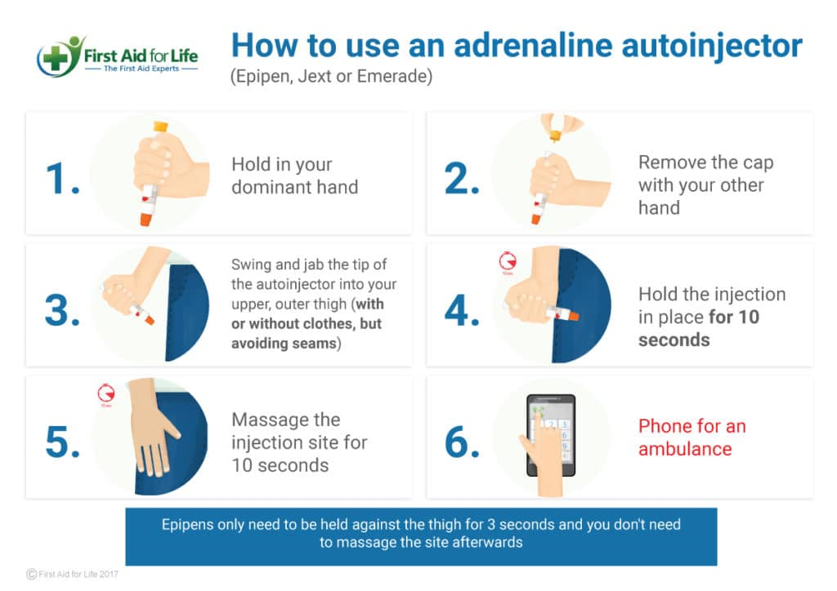

APPENDIX 3
Insert school name – Anaphylaxis & Allergies Risk Assessment

This form should be completed by the setting in liaison with the parents and the child, if appropriate. It should be shared with everyone who has contact with the child/young person.
Child/Young person: |  | Date of Birth:
Setting/School:  Phase: Primary/Secondary: |  | Key Worker/Teacher/Tutor:
Names and roles of other professionals involved in this Risk Assessment (i.e. Medical Specialist or School Nurse):

Date of Assessment: | Reassessment due:
I give permission for this to be shared with anyone who needs this information to keep the child/young person safe:
Signatures:

Setting Manager/Head teacher: Date

Parent/Guardian Date

What is this child allergic to?

Under which conditions is the allergy? Ingestion Direct contact Indirect contact

Does this child already have an Individual Healthcare Plan and a Personal Allergy Plan? YES NO
Summary of current medical evidence seen as part of the risk assessment (copies attached)

Describe the container the medication is kept in:
Key Questions - Please consider the activities below and insert any considerations than need to be put in place to enable the child to take part.
Crayons/painting:
Creative activities: i.e. craft paste/glue, pasta
Science type activity: i.e. bird feeders, planting seeds, food
Musical instrument sharing (cross contamination issue):
Cooking (food prep area and ingredients):
Mealtime:
kitchen prepared food (is allergy information available):
sandwiches:
Snacks (is allergy information available):
Drinks:
Celebrations: e.g., Birthday, Easter:
Hand washing (how accessible is this for the child):
Indoor play/PE (AAIs to be with the child):
Outdoor play/PE (AAIs to be with the child):
School field (AAIs to be with the child):
Forest school (AAIs to be with the child):
Offsite trips (are staff who accompany trip trained to use AAI):

Does the child know when they are having a reaction?

What signs are there that the child is having a reaction?

What action needs to be taken?

If the medication is stored in one secure place are there any occasions when this will not be close enough if required?
Yes No
If Yes state when and how this can be adjusted:

If the child is old enough – can the medication be carried by them throughout the day? Yes No
If No state reason:

How many adrenaline auto‑injectors are required in the setting?

Have all staff been trained to meet this child’s need?

What is the location of the school’s emergency backup AAI?

Outcome of Risk Assessment
Is an individual health care plan required? YES NO
Is a Personal Allergy Plan required? YES NO

