

USE OF EMERGENCY ASTHMA INHALER IN SCHOOL POLICY
Aim: This document is intended to provide guidance to schools that have identified a need for emergency asthma medication, including how to recognise asthma symptoms and administer emergency medication within the school setting or during school trips.
ESSENTIAL MANAGEMENT POLICY FOR:
Heads of Schools, Qualified first aiders, Visit Leaders, and Organisers
Date issued: 1st September 2018 by C Lloyd, Health and Safety Officer
Last reviewed: 15 July 2026 by C Lloyd Health and Safety Manager
Next review: July 2027

Date issued: by: insert name and job title

Next review: insert date

Approved by: | Mrs Rebecca Westall | Date: September 2026
Next review due by: | September 2027

1 INTRODUCTION
Asthma is a common lung condition that can cause occasional breathing difficulties. Although asthma affects both adults and children, it commonly starts in childhood. There is currently no long-term cure; however, asthma can be managed with treatments that keep the symptoms under control and allow children and young people to continue their normal, day-to-day activities. Some children do eventually grow out of asthma, but for others, it is a lifelong condition.
Asthma ‘triggers’ cause the already sensitive airways in an asthmatic to become narrowed and inflamed. Triggers are individual, and asthmatics can have more than one trigger. Common triggers are weather changes, viral infections e.g., colds and ‘flu, smoking, pollen, exercise, stress, animals, and house dust mite.
- One in 11 children in the UK suffers with asthma.
- Approximately 3 children in every classroom will have asthma.
- Asthma attacks kill 4 people in the UK every day.
- Every 10 seconds someone has a potentially life-threatening asthma attack.
- Between April 2019 - March 2023 there were 54 child deaths due to asthma.
The school's named Allergy Safety Lead shall have oversight of arrangements relating to pupils who have co-existing asthma and allergies. This includes ensuring that Individual Healthcare Plans, Allergy Action Plans and Asthma Action Plans are consistent, that emergency medication arrangements are reviewed annually, and that staff are aware of the emergency procedures contained within this policy.

1.1 Asthma and Allergy
Many pupils with allergies also have asthma. Poorly controlled asthma is recognised as a significant risk factor for severe allergic reactions and anaphylaxis.
Where a pupil has both asthma and a diagnosed allergy, the school should ensure that asthma management arrangements, Individual Healthcare Plans, Allergy Action Plans, Asthma Action Plans (if available) and emergency medication provision are considered together. Staff should be aware that breathing difficulties may occur as a result of either an asthma attack or anaphylaxis and should follow the appropriate emergency procedure without delay.

2 SYMPTOMS
The most common symptoms of asthma are:
- Wheezing (a whistling sound when breathing).
- Breathlessness.
- A tight chest – it may feel like a band tightening around it.
- Coughing.
Many things can cause these symptoms, but they are more likely to be asthma if they:
- Happen often and keep coming back.
- Are worse at night and early in the morning.
- Seem to happen in response to an asthma trigger like exercise of an allergy (such as to pollen or animal fur).
Mild symptoms are usually responsive to the child’s own inhaler and rest (stopping exercise). They would not normally require urgent medical attention.
Symptoms of an asthma attack will not necessarily occur suddenly and can often come on slowly over a few hours or days.
Signs and symptoms of an asthma attack are:
Signs that a person may be having an asthma attack include-
- Their symptoms are getting worse (cough, breathlessness, wheezing or tight chest)
- Their reliever inhaler (usually blue) is not helping.
- Difficulty Breathing - They are too breathless to speak, eat or sleep.
- Their breathing is getting faster and they feel like they cannot catch their breath.
- Their peak flow score is lower than normal.
- Children may also complain of a tummy or chest ache.
- Unable to talk or complete sentences. Some children will go very quiet.
- Nasal flaring.
- A blue / white tinge around the lips
- Going blue
The symptoms will not necessarily occur suddenly. In fact, they often come on slowly over a few hours or days.
IF A PUPIL IS HAVING AN ASTHMA ATTACK, FOLLOW THE EMERGENCY PROCEDURE
Do not delay starting the Emergency Procedure ANNEX A.
If a first aider is not immediately available, proceed directly to the Emergency Procedure.
3 INHALERS IN SCHOOLS
Previously it was illegal for schools to have spare emergency inhalers. Following campaigning from asthma charities and a change to the guidance, schools are now allowed, and indeed advised, to hold spare emergency reliever inhalers. 86% of children have been without their own inhaler because it was lost, they forgot to bring it, or it had expired.
The main risk of having emergency inhalers in school is that it could be administered inappropriately, e.g. to a breathless or panicky child who is not asthmatic. Schools must therefore ensure that only children who have been prescribed a reliever inhaler, should be given the emergency inhaler, and written parental consent must also have been obtained.
All staff working with children should have a basic understanding of asthma. Having an awareness of asthma, and its triggers, helps keep children safe. Staff should be able to recognise symptoms of an asthma attack have a basic knowledge of asthma medication and know what to do in the event of a child having an attack.
Trust schools are required to undertake an annual first aid needs assessment. This will identify if an emergency inhaler and supporting arrangements are necessary.
3.1 Inhalers
Inhalers are devices containing medication which can be breathed in. This type of medication is usually the main treatment for asthma, but other medication may also be needed for more severe cases.
Inhalers can help:
- Relieve symptoms when they occur (reliever inhalers). These are usually blue.
- Stop symptoms developing (preventer inhalers). These are usually brown/orange.
- Common brand names are “Clenil” or “Flixotide”
- Contain a low-dose steroid which reduces inflammation and swelling over time.
3.1.1 Storage of Inhalers
Children’s prescribed inhalers must be easily accessible in locations known to relevant staff. They should be protected from extreme temperatures and checked regularly to ensure they are in date, undamaged, and ready for use.
3.2 Volumatic Spacers
These spacers area empty tubes that are usually made of plastic, which slot onto the mouthpiece of the inhaler on one end. The person will breathe in the medication from the mouthpiece or mask on the spacer. Spacers help to get the right amount of medicine straight to the lungs.
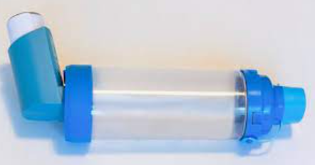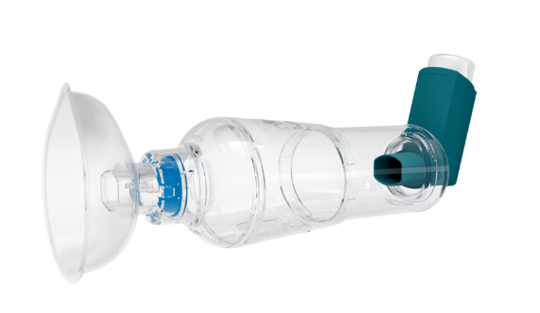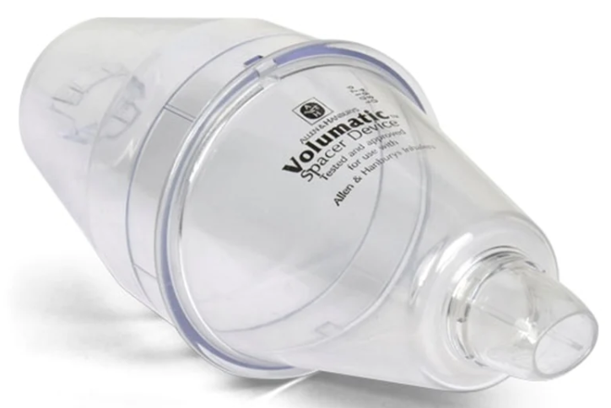

If the child requires a spacer as part of managing their asthma medication, it is important it is stored correctly:
- Spacers should not be kept in plastic bags, as this will cause it to build up static and reduce the effect of the asthma medicine.
- Spacers should be kept away from dust and liquids.
- If the spacer needs to be transported for school trips/ visits/ it should be ideally transported in a plastic-free medicine bag or pencil case with the inhaler.
3.3 Emergency Salbutamol Inhaler
From 1 October 2014 the Humans Medicines (Amendment) (No.2) Regulations 2014 allowed Schools in the UK to purchase a Salbutamol inhaler without prescription for use in emergencies when a child with asthma cannot access their own inhaler.
Inhalers / inhaler kits can be purchased online or via a local pharmacy. Pharmacists will need a request by the Principal or Headteacher (ideally on appropriately headed paper) stating:
- The name of the school for which the product is required.
- The purpose for which that product is required, and the total quantity required.
A template letter is provided at Annex D below.
The emergency inhaler must only be used for pupils who have a diagnosis of asthma or who have been prescribed a reliever inhaler AND whose parents have provided written consent for an emergency inhaler to be used.
Schools for the time being are not legally required to keep ‘spare’ emergency inhalers. However, they should consider doing so as part of their review of emergency medical provision/first aid needs. The decision should take into account how severe asthma is among pupils, how many pupils are affected, the contents of pupil’s IHPs and the needs and behaviours of the pupils, such as how consistently they bring their prescribed inhalers to school.
If the school Allergy Safety Lead determines a need for such Emergency medication, the following guidance should be noted and/or implemented:
The school should maintain an up-to-date Asthma Register identifying pupils prescribed reliever medication, parental consent status for emergency salbutamol use, and the location of any relevant Individual Healthcare Plans, Allergy or Asthma Action Plans. A hard copy should be kept within each Emergency Salbutamol Inhaler Kit.
The emergency Salbutamol inhaler can still be used even where a child has been prescribed an alternative reliever, e.g. Bricanyl. It will still help to relieve an asthma attack and could save their life.
It is the parent/guardian responsibility to inform us of any asthma diagnosis/treatment, although the school must seek this information from them prior to the pupil joining the school.
Annex B will be completed by the parent. The Asthma Register within each emergency kit will show whether parental consent has been given.
All pupils with asthma who have been prescribed a reliever (blue) inhaler should always carry it with them. If a pupil has an asthma attack and they do not have their inhaler with them and there is no access to immediate medical assistance from the school nurse (if applicable), then the Emergency Salbutamol Inhaler kit should be used. All staff should be made aware of the location of the Emergency inhaler/s by the appointed person for first aid.
Inhalers should be protected from extreme temperatures and checked regularly to ensure they are in date, undamaged, and ready for use.
When the kit has been located, the pupil should be identified and checked against the Asthma Register and whether parental consent has been given. The Emergency Procedure should then be followed.
Trip Leaders are responsible for taking an Emergency Salbutamol Inhaler kit with them, but only if there are pupils going on the trip whose names are on the Asthma Register and the school has assessed the need for spare Emergency Asthma inhalers.
4 TRAINING
Whilst all staff are required to undergo Allergy and Anaphylaxis training it is expected that all staff should have a basic awareness of asthma symptoms, triggers and emergency arrangements. Posters for information and instruction will be provided to all schools to inform staff accordingly.

Staff with specific responsibility for pupils with asthma, or who may be required to administer emergency Salbutamol, should complete Medication Awareness Training as a minimum. Asthma Training for Schools through the Trust's online provider Ihasco should also be considered for those staff responsible for pupils with asthma at the direction of the School Allergy Safety Lead.
Such staff may include;

- One to one Teaching Assistants
- Midday supervisors/lunchtime staff
- Breakfast/After school club staff
- Pastoral staff / SENCOs
- Trip and Visits staff
- PE staff

5 ACTION FOLLOWING EMERGENCY SALBUTAMOL INHALER USE
If the Emergency Salbutamol Inhaler is used for any pupil, the parent/s guardian must be informed as soon as possible and also by letter or email so that this information can also be passed onto the child’s GP. An example letter is shown in Annex B. That template can be followed, or an email sent to include all the information set out in the template. A copy must then be placed on the individual pupil’s personal file.
It will be the responsibility of the designated senior staff member to contact parents and request they provide a new inhaler for their child if the child has lost or misplaced their original inhaler, or it was empty at the time of the attack.
Where use of an emergency salbutamol inhaler is associated with a significant deterioration in a pupil's condition, a 999 call, attendance at hospital, failure of planned medical arrangements, or any identified procedural weakness, the incident should be reviewed in accordance with the school's Medical Conditions, First Aid and Incident Reporting arrangements. Consideration should also be given to reviewing the pupil's Individual Healthcare Plan and Asthma Action Plan where applicable.

6 ASSOCIATED HEALTH AND SAFETY POLICIES

TRUST

SET Allergies and Anaphylaxis Policy

SET Managing Medicines Policy

SET Supporting Pupils With Medical Conditions Policy

SCHOOL

Anaphylaxis and Allergies in School

Managing Medical Conditions in School Policy
7 REFERENCES
DFE: Allergy safety in schools statutory guidance
NHS: https://www.nhs.uk/conditions/asthma/
Department of Health: Emergency_inhalers_in_schools
Asthma UK: https://www.asthma.org.uk/advice/
Asthma and Lung UK: Reliever inhalers | Asthma + Lung UK

Annex A
EMERGENCY PROCEDURE IN THE EVENT OF AN ASTHMA ATTACK

1. | Encourage the person to sit up straight and keep calm.
2. | They should take one puff of their reliever inhaler (usually blue) every 30-60 second up to 10 puffs. Use a spacer if you have one.
3. | If they feel worse at any point or do not feel better after 10 puffs, call 999 for an ambulance.
4. | If the ambulance has not arrived after 10 minutes and their symptoms are not improving, repeat step 2.
5. | If their symptoms are no better after repeating step 2 and the ambulance has still not arrived, contact 999 again immediately.

ADDITIONAL NOTES
If step 3 is not reached and the child feels better after using the inhaler, they may return to school activities.
Even at step 2, if the child does not feel better or you are worried at ANYTIME before you have reached 10 puffs, call 999 for an ambulance.
Never be frightened of calling for help in an emergency.
All SET employees have the authority to make a 999 call without the need for permission. When doing so make it clear if it is a child who is suffering the attack.
The child’s parents or carers should be contacted after the ambulance has been called.
A member of staff should always accompany a child taken to hospital by ambulance and stay with them until a parent or carer arrives.


Annex B

EXAMPLE
PARENT/CARER CONSENT FORM
USE OF THE SCHOOL'S EMERGENCY SALBUTAMOL INHALER

Child's Name: _______________________________________
Date of Birth: ________________________________________
Class/Form: _________________________________________

Asthma Diagnosis
I confirm that my child has been diagnosed with asthma by a healthcare professional.

☐ Yes ☐ No

Medication Details
Name of prescribed reliever inhaler (e.g. Salbutamol/Ventolin):

_________________________________________________________

Does your child normally carry/have access to their own inhaler in school?
☐ Yes ☐ No

Parent/Carer Consent
I confirm that:

• My child has a diagnosed asthma condition.
• My child has been prescribed the reliever inhaler detailed above.
• I will provide the school with an in-date inhaler, clearly labelled with my child's name.
• I will inform the school of any changes to my child's medication or asthma management.

In the event that my child displays symptoms of asthma and their prescribed inhaler is unavailable, empty, damaged or otherwise unusable, I consent for my child to receive salbutamol from an emergency inhaler held by the school for such emergencies.

Parent/Carer Name: _________________________________

Signature: ___________________________________________

Date: ________________________________________________

Contact Telephone Number: _________________________

Email Address: ______________________________________

Annex C
EXAMPLE
SPECIMEN LETTER TO INFORM PARENTS OF EMERGENCY SALBUTAMOL INHALER USE

Child’s name: ………………………………………………………………………………………...
Class………………………………………………… Date………………………………………………

Dear…………………………………………….

This letter is to formally notify you that………………………………….has had problems with his / her breathing today.
A member of staff helped them to use their asthma inhaler. They did not have their own asthma inhaler with them, so a member of staff helped them to use the emergency asthma inhaler containing salbutamol. They were given ……… puffs.
Their own asthma inhaler was not working, so a member of staff helped them to use the emergency asthma inhaler containing salbutamol. They were given ……… puffs. [Delete as appropriate]
Although they soon felt better, we would strongly advise that you have your child seen by your own doctor as soon as possible.
Yours sincerely,

Annex D
EXAMPLE
TEMPLATE LETTER TO LOCAL PHARMACIES FOR THE SUPPLY OF EMERGENCY SALBUTAMOL INHALERS
[To be completed on headed school paper]

Date

In accordance with the Guidance on the Use of Emergency Salbutamol Inhalers in Schools (Department of Health, 2015), please accept this letter as an official request to supply our school [insert name]:

- [Quantity] Emergency Asthma Kit
- [Quantity] Salbutamol inhaler(s)
- [Quantity] Volumatic Spacer device(s) (if required)
These will be used solely for the purpose of providing emergency treatment to pupils diagnosed with asthma, or those who have been prescribed a salbutamol inhaler, in line with the school’s asthma policy.

Signed: _______________________________ Date: _________________
Print name:
Head Teacher/Principal

